Projet Gestion Contrat

Base de données
13/07/2018

#------------------------------------------------------------
# Script MySQL.
#------------------------------------------------------------
CREATE DATABASE gestioncontrat CHARACTER SET utf8;
USE gestioncontrat;
#------------------------------------------------------------
# Table: typecontrat
#------------------------------------------------------------
CREATE TABLE typecontrat(
id Int Auto_increment NOT NULL ,
libelle Varchar (255) NOT NULL ,
descriptif Varchar (255) NOT NULL ,
modalites Varchar (255) NOT NULL
,CONSTRAINT typecontrat_PK PRIMARY KEY (id)
)ENGINE=InnoDB;
#------------------------------------------------------------
# Table: date
#------------------------------------------------------------
CREATE TABLE date(
date Date NOT NULL
,CONSTRAINT date_PK PRIMARY KEY (date)
)ENGINE=InnoDB;
#------------------------------------------------------------
# Table: contrat
#------------------------------------------------------------
CREATE TABLE contrat(
id Int Auto_increment NOT NULL ,
numero Int NOT NULL ,
libelle Varchar (25) NOT NULL ,
prestataire Varchar (255) NOT NULL ,
client Varchar (255) NOT NULL ,
descriptif Varchar (255) NOT NULL ,
modalites Varchar (255) NOT NULL ,
id_typecontrat Int NOT NULL ,
date Date NOT NULL ,
date_finir Date NOT NULL ,
date_approuver Date NOT NULL
,CONSTRAINT contrat_PK PRIMARY KEY (id)
,CONSTRAINT contrat_typecontrat_FK FOREIGN KEY (id_typecontrat) REFERENCES typecontrat(id)
,CONSTRAINT contrat_date0_FK FOREIGN KEY (date) REFERENCES date(date)
,CONSTRAINT contrat_date1_FK FOREIGN KEY (date_finir) REFERENCES date(date)
,CONSTRAINT contrat_date2_FK FOREIGN KEY (date_approuver) REFERENCES date(date)
)ENGINE=InnoDB;
#------------------------------------------------------------
# Table: avenant
#------------------------------------------------------------
CREATE TABLE avenant(
id Int Auto_increment NOT NULL ,
modalites Varchar (255) NOT NULL ,
dateavenant Date NOT NULL ,
id_contrat Int NOT NULL
,CONSTRAINT avenant_PK PRIMARY KEY (id)
,CONSTRAINT avenant_contrat_FK FOREIGN KEY (id_contrat) REFERENCES contrat(id)
)ENGINE=InnoDB;
#------------------------------------------------------------
# Table: facturation
#------------------------------------------------------------
CREATE TABLE facturation(
id Int Auto_increment NOT NULL ,
numero Int NOT NULL ,
libelle Varchar (255) NOT NULL ,
emeteur Varchar (255) NOT NULL ,
recepteur Varchar (255) NOT NULL ,
datefacture Date NOT NULL ,
echeance Date NOT NULL ,
modalites Varchar (255) NOT NULL ,
encaissement Varchar (255) NOT NULL
,CONSTRAINT facturation_PK PRIMARY KEY (id)
)ENGINE=InnoDB;
#------------------------------------------------------------
# Table: devis
#------------------------------------------------------------
CREATE TABLE devis(
id Int Auto_increment NOT NULL ,
numero Int NOT NULL ,
libelle Varchar (25) NOT NULL ,
emeteur Varchar (255) NOT NULL ,
recepteur Varchar (255) NOT NULL ,
prestation Varchar (255) NOT NULL ,
datedevis Date NOT NULL
,CONSTRAINT devis_PK PRIMARY KEY (id)
)ENGINE=InnoDB;
#------------------------------------------------------------
# Table: prestation
#------------------------------------------------------------
CREATE TABLE prestation(
id Int Auto_increment NOT NULL ,
activite Varchar (50) NOT NULL ,
description Varchar (255) NOT NULL ,
designation Varchar (255) NOT NULL ,
tva Decimal NOT NULL ,
prixh Decimal NOT NULL ,
Heuretotale Int NOT NULL
,CONSTRAINT prestation_PK PRIMARY KEY (id)
)ENGINE=InnoDB;
#------------------------------------------------------------
# Table: utilisateur
#------------------------------------------------------------
CREATE TABLE utilisateur(
id Int Auto_increment NOT NULL ,
pseudo Varchar (255) NOT NULL ,
motdepasse Varchar (255) NOT NULL ,
nom Varchar (255) NOT NULL ,
prenom Varchar (255) NOT NULL ,
adresse Varchar (255) NOT NULL ,
telephone Int NOT NULL ,
email Varchar (255) NOT NULL ,
datedenaissance Date NOT NULL ,
role Varchar (255) NOT NULL
,CONSTRAINT utilisateur_PK PRIMARY KEY (id)
)ENGINE=InnoDB;
#------------------------------------------------------------
# Table: entreprise
#------------------------------------------------------------
CREATE TABLE entreprise(
id Int Auto_increment NOT NULL ,
nom Varchar (255) NOT NULL ,
siret Int NOT NULL ,
qualification Varchar (255) NOT NULL ,
adresse Varchar (255) NOT NULL ,
telephone Int NOT NULL ,
email Varchar (255) NOT NULL
,CONSTRAINT entreprise_PK PRIMARY KEY (id)
)ENGINE=InnoDB;
#------------------------------------------------------------
# Table: representant
#------------------------------------------------------------
CREATE TABLE representant(
id Int Auto_increment NOT NULL ,
nom Varchar (255) NOT NULL ,
titre Varchar (255) NOT NULL ,
prenom Varchar (255) NOT NULL
,CONSTRAINT representant_PK PRIMARY KEY (id)
)ENGINE=InnoDB;
#------------------------------------------------------------
# Table: produit
#------------------------------------------------------------
CREATE TABLE produit(
id Int Auto_increment NOT NULL ,
nom Varchar (100) NOT NULL ,
quantite Int NOT NULL ,
devise Varchar (100) NOT NULL ,
prixunitaire DECIMAL (15,3) NOT NULL ,
tva Decimal NOT NULL ,
description Varchar (255) NOT NULL
,CONSTRAINT produit_PK PRIMARY KEY (id)
)ENGINE=InnoDB;
#------------------------------------------------------------
# Table: signer
#------------------------------------------------------------
CREATE TABLE signer(
id Int NOT NULL ,
id_entreprise Int NOT NULL ,
id_representant Int NOT NULL
,CONSTRAINT signer_PK PRIMARY KEY (id,id_entreprise,id_representant)
,CONSTRAINT signer_contrat_FK FOREIGN KEY (id) REFERENCES contrat(id)
,CONSTRAINT signer_entreprise0_FK FOREIGN KEY (id_entreprise) REFERENCES entreprise(id)
,CONSTRAINT signer_representant1_FK FOREIGN KEY (id_representant) REFERENCES representant(id)
)ENGINE=InnoDB;
#------------------------------------------------------------
# Table: generer
#------------------------------------------------------------
CREATE TABLE generer(
id Int NOT NULL ,
id_facturation Int NOT NULL
,CONSTRAINT generer_PK PRIMARY KEY (id,id_facturation)
,CONSTRAINT generer_prestation_FK FOREIGN KEY (id) REFERENCES prestation(id)
,CONSTRAINT generer_facturation0_FK FOREIGN KEY (id_facturation) REFERENCES facturation(id)
)ENGINE=InnoDB;
#------------------------------------------------------------
# Table: lier
#------------------------------------------------------------
CREATE TABLE lier(
id Int NOT NULL ,
id_prestation Int NOT NULL
,CONSTRAINT lier_PK PRIMARY KEY (id,id_prestation)
,CONSTRAINT lier_devis_FK FOREIGN KEY (id) REFERENCES devis(id)
,CONSTRAINT lier_prestation0_FK FOREIGN KEY (id_prestation) REFERENCES prestation(id)
)ENGINE=InnoDB;
#------------------------------------------------------------
# Table: concerner
#------------------------------------------------------------
CREATE TABLE concerner(
id Int NOT NULL ,
id_prestation Int NOT NULL
,CONSTRAINT concerner_PK PRIMARY KEY (id,id_prestation)
,CONSTRAINT concerner_contrat_FK FOREIGN KEY (id) REFERENCES contrat(id)
,CONSTRAINT concerner_prestation0_FK FOREIGN KEY (id_prestation) REFERENCES prestation(id)
)ENGINE=InnoDB;
#------------------------------------------------------------
# Table: interesser
#------------------------------------------------------------
CREATE TABLE interesser(
id Int NOT NULL ,
id_utilisateur Int NOT NULL
,CONSTRAINT interesser_PK PRIMARY KEY (id,id_utilisateur)
,CONSTRAINT interesser_contrat_FK FOREIGN KEY (id) REFERENCES contrat(id)
,CONSTRAINT interesser_utilisateur0_FK FOREIGN KEY (id_utilisateur) REFERENCES utilisateur(id)
)ENGINE=InnoDB;
#------------------------------------------------------------
# Table: composer
#------------------------------------------------------------
CREATE TABLE composer(
id Int NOT NULL ,
id_devis Int NOT NULL
,CONSTRAINT composer_PK PRIMARY KEY (id,id_devis)
,CONSTRAINT composer_produit_FK FOREIGN KEY (id) REFERENCES produit(id)
,CONSTRAINT composer_devis0_FK FOREIGN KEY (id_devis) REFERENCES devis(id)
)ENGINE=InnoDB;
#------------------------------------------------------------
# Table: facturer
#------------------------------------------------------------
CREATE TABLE facturer(
id Int NOT NULL ,
id_facturation Int NOT NULL
,CONSTRAINT facturer_PK PRIMARY KEY (id,id_facturation)
,CONSTRAINT facturer_produit_FK FOREIGN KEY (id) REFERENCES produit(id)
,CONSTRAINT facturer_facturation0_FK FOREIGN KEY (id_facturation) REFERENCES facturation(id)
)ENGINE=InnoDB;

MCD version1

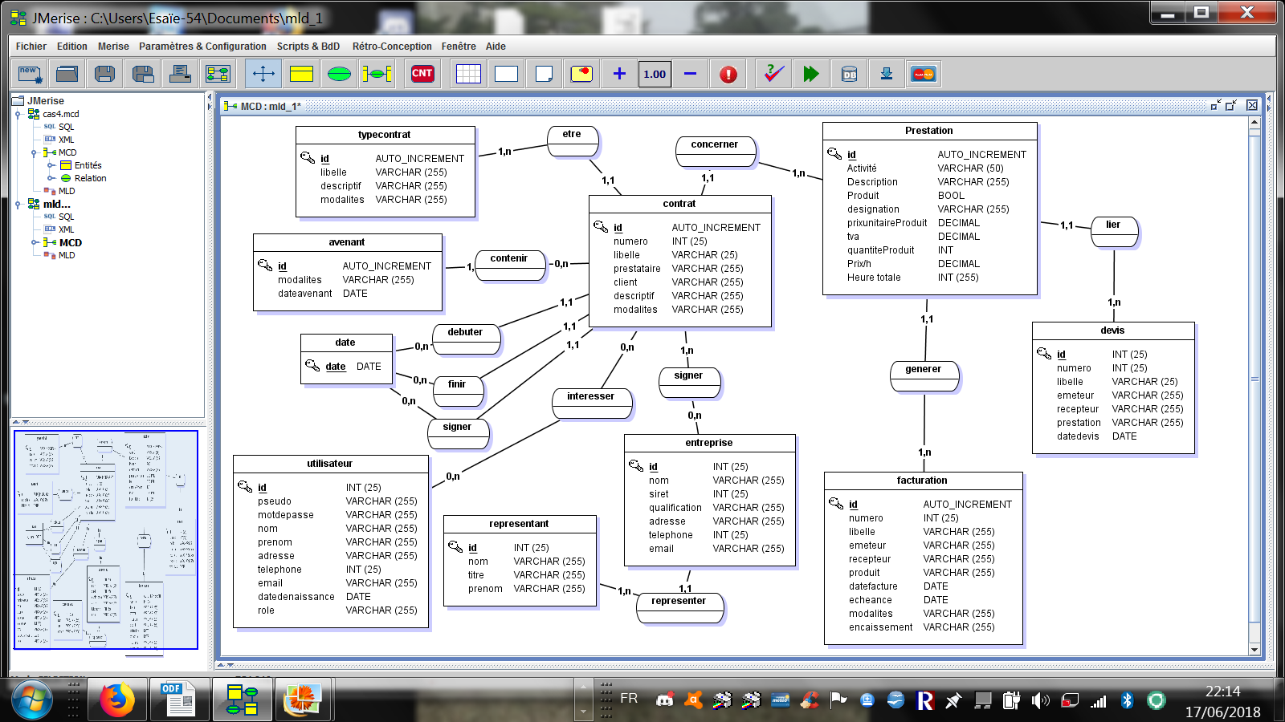

MLD version1

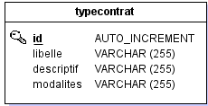
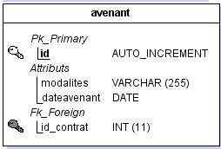
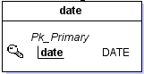
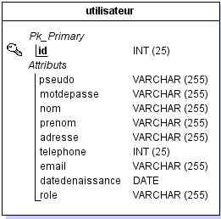
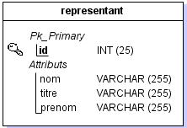
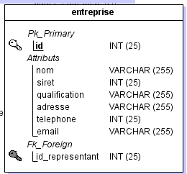
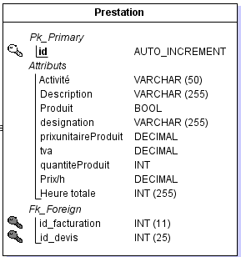
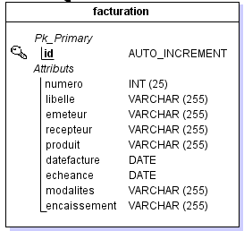
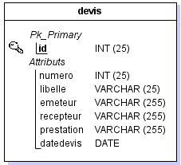
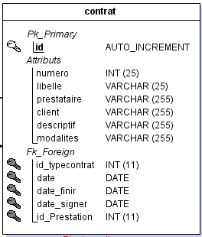
MCD
version5

USER STORY (1)
--> En tant que Utilisateur, je veux me connecter

Interface
User
Utlisateur
- pseudo : Strihg
- motdepasse : String
- nom : String
- prenon : String
- Role : String
UtilisateurService
- utilisateur : Utilisateur
+ connecter ( ) : void
+ deconnecter ( ) : void
+ creerUtilisateur ( ) : void
+ verifierUtilisateur ( ) : void
+ getPseudo ( )
+ getMotdepasse ( )

#------------------------------------------------------------
# Script MySQL.
#------------------------------------------------------------
CREATE DATABASE gestioncontrat CHARACTER SET utf8;
USE gestioncontrat;
#------------------------------------------------------------
# Table: typecontrat
#------------------------------------------------------------
CREATE TABLE typecontrat(
id Int Auto_increment NOT NULL ,
libelle Varchar (255) NOT NULL
,CONSTRAINT typecontrat_PK PRIMARY KEY (id)
)ENGINE=InnoDB;
#------------------------------------------------------------
# Table: prestation
#------------------------------------------------------------
CREATE TABLE prestation(
id Int Auto_increment NOT NULL ,
nom Varchar (255) NOT NULL ,
description Varchar (255) NOT NULL ,
tva Decimal NOT NULL ,
prixhoraire Decimal NOT NULL ,
heuretotale Int NOT NULL ,
devise Varchar (255) NOT NULL
,CONSTRAINT prestation_PK PRIMARY KEY (id)
)ENGINE=InnoDB;
#------------------------------------------------------------
# Table: utilisateur
#------------------------------------------------------------
CREATE TABLE utilisateur(
pseudo Varchar (255) NOT NULL ,
motdepasse Varchar (255) NOT NULL ,
nom Varchar (255) NOT NULL ,
prenom Varchar (255) NOT NULL ,
telephone Int NOT NULL ,
email Varchar (255) NOT NULL ,
datedenaissance Date NOT NULL ,
role Varchar (255) NOT NULL ,
numerorue Varchar (255) NOT NULL ,
cp Int NOT NULL ,
ville Varchar (255) NOT NULL ,
pays Varchar (255) NOT NULL
,CONSTRAINT utilisateur_PK PRIMARY KEY (pseudo)
)ENGINE=InnoDB;
#------------------------------------------------------------
# Table: contrat
#------------------------------------------------------------
CREATE TABLE contrat(
numero Int Auto_increment NOT NULL ,
libelle Varchar (25) NOT NULL ,
descriptif Varchar (255) NOT NULL ,
datededebut Date NOT NULL ,
datedefin Date NOT NULL ,
datedesignature Date NOT NULL ,
id Int NOT NULL ,
pseudo Varchar (255) NOT NULL
,CONSTRAINT contrat_PK PRIMARY KEY (numero)
,CONSTRAINT contrat_typecontrat_FK FOREIGN KEY (id) REFERENCES typecontrat(id)
,CONSTRAINT contrat_utilisateur0_FK FOREIGN KEY (pseudo) REFERENCES utilisateur(pseudo)
)ENGINE=InnoDB;
#------------------------------------------------------------
# Table: avenant
#------------------------------------------------------------
CREATE TABLE avenant(
id Int Auto_increment NOT NULL ,
modalites Varchar (255) NOT NULL ,
dateavenant Date NOT NULL ,
numero Int NOT NULL
,CONSTRAINT avenant_PK PRIMARY KEY (id)
,CONSTRAINT avenant_contrat_FK FOREIGN KEY (numero) REFERENCES contrat(numero)
)ENGINE=InnoDB;
#------------------------------------------------------------
# Table: facture
#------------------------------------------------------------
CREATE TABLE facture(
numero Int Auto_increment NOT NULL ,
libelle Varchar (255) NOT NULL ,
datefacture Date NOT NULL ,
pseudo Varchar (255) NOT NULL
,CONSTRAINT facture_PK PRIMARY KEY (numero)
,CONSTRAINT facture_utilisateur_FK FOREIGN KEY (pseudo) REFERENCES utilisateur(pseudo)
)ENGINE=InnoDB;
#------------------------------------------------------------
# Table: devis
#------------------------------------------------------------
CREATE TABLE devis(
numero Int Auto_increment NOT NULL ,
libelle Varchar (25) NOT NULL ,
datedevis Date NOT NULL ,
pseudo Varchar (255) NOT NULL
,CONSTRAINT devis_PK PRIMARY KEY (numero)
,CONSTRAINT devis_utilisateur_FK FOREIGN KEY (pseudo) REFERENCES utilisateur(pseudo)
)ENGINE=InnoDB;
#------------------------------------------------------------
# Table: entreprise
#------------------------------------------------------------
CREATE TABLE entreprise(
id Int Auto_increment NOT NULL ,
nom Varchar (255) NOT NULL ,
siret Int NOT NULL ,
qualification Varchar (255) NOT NULL ,
telephone Int NOT NULL ,
email Varchar (255) NOT NULL ,
representant Varchar (255) NOT NULL ,
etat Bool NOT NULL ,
numerorue Varchar (255) NOT NULL ,
cp Int NOT NULL ,
ville Varchar (255) NOT NULL ,
pays Varchar (255) NOT NULL
,CONSTRAINT entreprise_PK PRIMARY KEY (id)
)ENGINE=InnoDB;
#------------------------------------------------------------
# Table: produit
#------------------------------------------------------------
CREATE TABLE produit(
id Int Auto_increment NOT NULL ,
nom Varchar (100) NOT NULL ,
quantite Int NOT NULL ,
devise Varchar (100) NOT NULL ,
prixunitaire DECIMAL (15,3) NOT NULL ,
tva Decimal NOT NULL ,
description Varchar (255) NOT NULL
,CONSTRAINT produit_PK PRIMARY KEY (id)
)ENGINE=InnoDB;
#------------------------------------------------------------
# Table: signer
#------------------------------------------------------------
CREATE TABLE signer(
id Int NOT NULL ,
numero Int NOT NULL
,CONSTRAINT signer_PK PRIMARY KEY (id,numero)
,CONSTRAINT signer_entreprise_FK FOREIGN KEY (id) REFERENCES entreprise(id)
,CONSTRAINT signer_contrat0_FK FOREIGN KEY (numero) REFERENCES contrat(numero)
)ENGINE=InnoDB;
#------------------------------------------------------------
# Table: generer
#------------------------------------------------------------
CREATE TABLE generer(
id Int NOT NULL ,
numero Int NOT NULL
,CONSTRAINT generer_PK PRIMARY KEY (id,numero)
,CONSTRAINT generer_prestation_FK FOREIGN KEY (id) REFERENCES prestation(id)
,CONSTRAINT generer_facture0_FK FOREIGN KEY (numero) REFERENCES facture(numero)
)ENGINE=InnoDB;
#------------------------------------------------------------
# Table: lier
#------------------------------------------------------------
CREATE TABLE lier(
numero Int NOT NULL ,
id Int NOT NULL
,CONSTRAINT lier_PK PRIMARY KEY (numero,id)
,CONSTRAINT lier_devis_FK FOREIGN KEY (numero) REFERENCES devis(numero)
,CONSTRAINT lier_prestation0_FK FOREIGN KEY (id) REFERENCES prestation(id)
)ENGINE=InnoDB;
#------------------------------------------------------------
# Table: concerner
#------------------------------------------------------------
CREATE TABLE concerner(
numero Int NOT NULL ,
id Int NOT NULL
,CONSTRAINT concerner_PK PRIMARY KEY (numero,id)
,CONSTRAINT concerner_contrat_FK FOREIGN KEY (numero) REFERENCES contrat(numero)
,CONSTRAINT concerner_prestation0_FK FOREIGN KEY (id) REFERENCES prestation(id)
)ENGINE=InnoDB;
#------------------------------------------------------------
# Table: composer
#------------------------------------------------------------
CREATE TABLE composer(
id Int NOT NULL ,
numero Int NOT NULL
,CONSTRAINT composer_PK PRIMARY KEY (id,numero)
,CONSTRAINT composer_produit_FK FOREIGN KEY (id) REFERENCES produit(id)
,CONSTRAINT composer_devis0_FK FOREIGN KEY (numero) REFERENCES devis(numero)
)ENGINE=InnoDB;
#------------------------------------------------------------
# Table: facturer
#------------------------------------------------------------
CREATE TABLE facturer(
id Int NOT NULL ,
numero Int NOT NULL
,CONSTRAINT facturer_PK PRIMARY KEY (id,numero)
,CONSTRAINT facturer_produit_FK FOREIGN KEY (id) REFERENCES produit(id)
,CONSTRAINT facturer_facture0_FK FOREIGN KEY (numero) REFERENCES facture(numero)
)ENGINE=InnoDB;
#------------------------------------------------------------
# Table: emettre
#------------------------------------------------------------
CREATE TABLE emettre(
numero Int NOT NULL ,
id Int NOT NULL
,CONSTRAINT emettre_PK PRIMARY KEY (numero,id)
,CONSTRAINT emettre_devis_FK FOREIGN KEY (numero) REFERENCES devis(numero)
,CONSTRAINT emettre_entreprise0_FK FOREIGN KEY (id) REFERENCES entreprise(id)
)ENGINE=InnoDB;
#------------------------------------------------------------
# Table: associer
#------------------------------------------------------------
CREATE TABLE associer(
numero Int NOT NULL ,
id Int NOT NULL
,CONSTRAINT associer_PK PRIMARY KEY (numero,id)
,CONSTRAINT associer_facture_FK FOREIGN KEY (numero) REFERENCES facture(numero)
,CONSTRAINT associer_entreprise0_FK FOREIGN KEY (id) REFERENCES entreprise(id)
)ENGINE=InnoDB;
ALTER TABLE entreprise DROP etat;
ALTER TABLE prestation DROP tva;
ALTER TABLE prestation DROP prixhoraire;
ALTER TABLE prestation DROP heuretotale;
ALTER TABLE prestation DROP devise;

Bade de données (23/08/2018)
#------------------------------------------------------------
# Script MySQL.
#------------------------------------------------------------

#------------------------------------------------------------
# Table: typecontrat
#------------------------------------------------------------

CREATE TABLE typecontrat(
id Int Auto_increment NOT NULL ,
libelle Varchar (255) NOT NULL
,CONSTRAINT typecontrat_PK PRIMARY KEY (id)
)ENGINE=InnoDB;

#------------------------------------------------------------
# Table: date
#------------------------------------------------------------

CREATE TABLE date(
date Date NOT NULL
,CONSTRAINT date_PK PRIMARY KEY (date)
)ENGINE=InnoDB;

#------------------------------------------------------------
# Table: utilisateur
#------------------------------------------------------------

CREATE TABLE utilisateur(
pseudo Varchar (255) NOT NULL ,
motdepasse Varchar (255) NOT NULL ,
nom Varchar (255) NOT NULL ,
prenom Varchar (255) NOT NULL ,
telephone Int NOT NULL ,
email Varchar (255) NOT NULL ,
datedenaissance Date NOT NULL ,
role Varchar (255) NOT NULL ,
numerorue Varchar (255) NOT NULL ,
cp Int NOT NULL ,
ville Varchar (255) NOT NULL ,
pays Varchar (255) NOT NULL
,CONSTRAINT utilisateur_PK PRIMARY KEY (pseudo)
)ENGINE=InnoDB;

#------------------------------------------------------------
# Table: entreprise
#------------------------------------------------------------

CREATE TABLE entreprise(
id Int Auto_increment NOT NULL ,
nom Varchar (255) NOT NULL ,
siret Int NOT NULL ,
qualification Varchar (255) NOT NULL ,
telephone Int NOT NULL ,
email Varchar (255) NOT NULL ,
numerorue Varchar (255) NOT NULL ,
cp Int NOT NULL ,
ville Varchar (255) NOT NULL ,
pays Varchar (255) NOT NULL ,
representant Varchar (100) NOT NULL
,CONSTRAINT entreprise_PK PRIMARY KEY (id)
)ENGINE=InnoDB;

#------------------------------------------------------------
# Table: contrat
#------------------------------------------------------------

CREATE TABLE contrat(
numero Int Auto_increment NOT NULL ,
libelle Varchar (255) NOT NULL ,
description Varchar (255) NOT NULL ,
id Int NOT NULL ,
date Date NOT NULL ,
date_finir Date NOT NULL ,
date_approuver Date NOT NULL ,
id_entreprise Int NOT NULL ,
pseudo Varchar (255) NOT NULL ,
id_entreprise_concerner Int NOT NULL
,CONSTRAINT contrat_PK PRIMARY KEY (numero)

,CONSTRAINT contrat_typecontrat_FK FOREIGN KEY (id) REFERENCES typecontrat(id)
,CONSTRAINT contrat_date0_FK FOREIGN KEY (date) REFERENCES date(date)
,CONSTRAINT contrat_date1_FK FOREIGN KEY (date_finir) REFERENCES date(date)
,CONSTRAINT contrat_date2_FK FOREIGN KEY (date_approuver) REFERENCES date(date)
,CONSTRAINT contrat_entreprise3_FK FOREIGN KEY (id_entreprise) REFERENCES entreprise(id)
,CONSTRAINT contrat_utilisateur4_FK FOREIGN KEY (pseudo) REFERENCES utilisateur(pseudo)
,CONSTRAINT contrat_entreprise5_FK FOREIGN KEY (id_entreprise_concerner) REFERENCES entreprise(id)
)ENGINE=InnoDB;

#------------------------------------------------------------
# Table: avenant
#------------------------------------------------------------

CREATE TABLE avenant(
id Int Auto_increment NOT NULL ,
modalites Varchar (255) NOT NULL ,
dateavenant Date NOT NULL ,
numero Int NOT NULL
,CONSTRAINT avenant_PK PRIMARY KEY (id)

,CONSTRAINT avenant_contrat_FK FOREIGN KEY (numero) REFERENCES contrat(numero)
)ENGINE=InnoDB;

#------------------------------------------------------------
# Table: facture
#------------------------------------------------------------

CREATE TABLE facture(
numero Int Auto_increment NOT NULL ,
libelle Varchar (255) NOT NULL ,
description Varchar (255) NOT NULL ,
pseudo Varchar (255) NOT NULL ,
date Date NOT NULL ,
id Int NOT NULL ,
id_entreprise Int NOT NULL
,CONSTRAINT facture_PK PRIMARY KEY (numero)

,CONSTRAINT facture_utilisateur_FK FOREIGN KEY (pseudo) REFERENCES utilisateur(pseudo)
,CONSTRAINT facture_date0_FK FOREIGN KEY (date) REFERENCES date(date)
,CONSTRAINT facture_entreprise1_FK FOREIGN KEY (id) REFERENCES entreprise(id)
,CONSTRAINT facture_entreprise2_FK FOREIGN KEY (id_entreprise) REFERENCES entreprise(id)
)ENGINE=InnoDB;

#------------------------------------------------------------
# Table: devis
#------------------------------------------------------------

CREATE TABLE devis(
numero Int Auto_increment NOT NULL ,
libelle Varchar (255) NOT NULL ,
description Varchar (255) NOT NULL ,
id Int NOT NULL ,
pseudo Varchar (255) NOT NULL ,
date Date NOT NULL ,
id_entreprise Int NOT NULL
,CONSTRAINT devis_PK PRIMARY KEY (numero)

,CONSTRAINT devis_entreprise_FK FOREIGN KEY (id) REFERENCES entreprise(id)
,CONSTRAINT devis_utilisateur0_FK FOREIGN KEY (pseudo) REFERENCES utilisateur(pseudo)
,CONSTRAINT devis_date1_FK FOREIGN KEY (date) REFERENCES date(date)
,CONSTRAINT devis_entreprise2_FK FOREIGN KEY (id_entreprise) REFERENCES entreprise(id)
)ENGINE=InnoDB;

#------------------------------------------------------------
# Table: produit
#------------------------------------------------------------

CREATE TABLE produit(
id Int Auto_increment NOT NULL ,
nom Varchar (100) NOT NULL ,
quantite Int NOT NULL ,
devise Varchar (100) NOT NULL ,
prixunitaire DECIMAL (15,3) NOT NULL ,
tva Decimal NOT NULL ,
description Varchar (255) NOT NULL
,CONSTRAINT produit_PK PRIMARY KEY (id)
)ENGINE=InnoDB;

#------------------------------------------------------------
# Table: composer
#------------------------------------------------------------

CREATE TABLE composer(
id Int NOT NULL ,
numero Int NOT NULL
,CONSTRAINT composer_PK PRIMARY KEY (id,numero)

,CONSTRAINT composer_produit_FK FOREIGN KEY (id) REFERENCES produit(id)
,CONSTRAINT composer_devis0_FK FOREIGN KEY (numero) REFERENCES devis(numero)
)ENGINE=InnoDB;

#------------------------------------------------------------
# Table: facturer
#------------------------------------------------------------

CREATE TABLE facturer(
id Int NOT NULL ,
numero Int NOT NULL
,CONSTRAINT facturer_PK PRIMARY KEY (id,numero)

,CONSTRAINT facturer_produit_FK FOREIGN KEY (id) REFERENCES produit(id)
,CONSTRAINT facturer_facture0_FK FOREIGN KEY (numero) REFERENCES facture(numero)
)ENGINE=InnoDB;

